**Excel Assignment - 10**

1. See the below picture and create the exact table with exact formatting. Font – Times New Roman Size – 14, Color of first-line Orange.

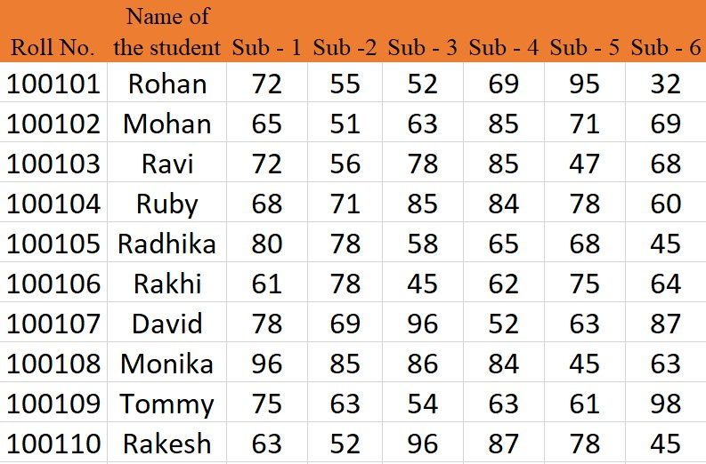

2. From the above table use Sum Formula and find the total for each student.

Ans. = SUM (C2:H2) and drag this for all

3. Calculate the Average for each student in the next row. Use Formulas.

Ans. = AVERAGE (C2:H2) and drag it for all

4. Calculate the Rank for each student. Use Formulas.

Ans. = RANK (I2, $I$2:$I$11, 0) and drag it for all

5. Calculate the Percentage for each student. Use Formulas. Round off the decimals up to 2 points.

Ans. =ROUND ((I2/6), 2) and drag it for all